Name:______________ ID:_____________ Section:________

Q1: A software engineering team at SoftVision Pvt. Ltd. has developed an intelligent system that predicts whether a software module is defective (C₁) or non-defective (C₂) based on historical project metrics (e.g., code complexity, number of commits, and developer experience).
During system testing, the model outputs the following posterior probabilities for four newly developed modules (M₁–M₄):

Module(x) | P(Defective |x ) | P(Non-Defective|x) | Class
M1 | 0.85 | 0.15 | Défective (c1)
M2 | 0.45 | 0.55 | Non-Défective (c2)
M3 | 0.30 | 0.70 | Non-Défective (c2)
M4 | 0.50 | 0.50 | Either one , not sure
The project manager wants to assess the performance limit of this predictive system— the best accuracy achievable even under optimal classification (known as the Bayes optimal performance).

- Determine the Bayes optimal decision (predicted class) for each module (M₁–M₄). (Fill in the table if you think required).

All ready filled in table

- Compute the Bayes Error Rate using the formula:
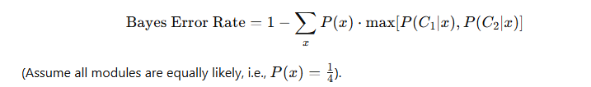
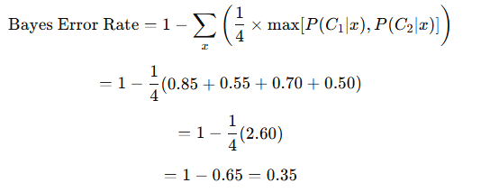
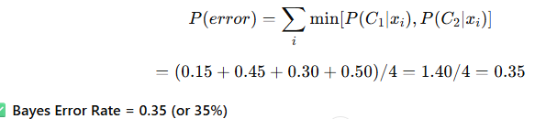

- Identify which module contributes most to the overall error and explain why.

M4 contributes the most (0.50) → Because both classes have equal probability (no confidence), highest uncertainty.

- Suppose the Bayes Error Rate on a problem is 0.20. Using the theoretical bound, find the maximum possible error of the 1-NN rule.
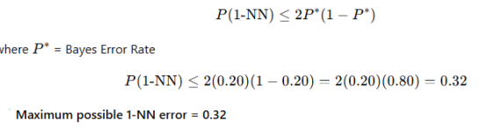

- If the dataset size increases indefinitely, what value will the 1-NN error approach?

1-NN error → 2 × Bayes Error × (1 – Bayes Error) For large data, it approaches the Bayes Error. So 1-NN error → 0.20

- If the Bayes Error were 0 (perfect separability), what would the 1-NN error theoretically be?

If Bayes Error = 0 (perfect separability): , 1-NN error=0 , No error (perfect prediction)

A software company wants to predict whether a module will be “Buggy” or “Non-Buggy” based on its development characteristics.
Module | Code_Complexity | Team_Experience | Test_Coverage | Review_Status | Buggy
M1 | High | Low | Low | Not_Reviewed | Yes
M2 | High | Medium | Medium | Reviewed | No
M3 | Medium | High | Low | Reviewed | No
M4 | Low | High | High | Reviewed | No
M5 | Medium | Low | Medium | Not_Reviewed | Yes
M6 | High | Medium | High | Reviewed | No
M7 | Low | Low | Low | Not_Reviewed | Yes
M8 | Medium | High | High | Reviewed | No
Use the ID3 Algorithm to build a decision tree that predicts whether a software module will be buggy or non-buggy (explore the root node and expand only one child of your choice).
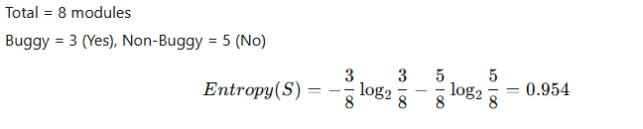

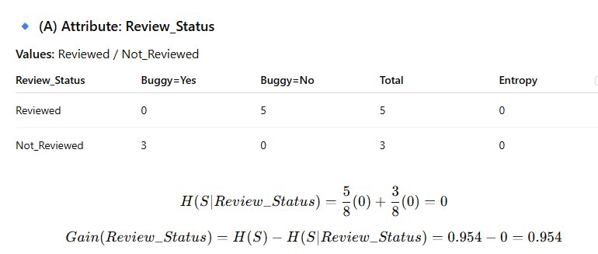

Similarly for All :

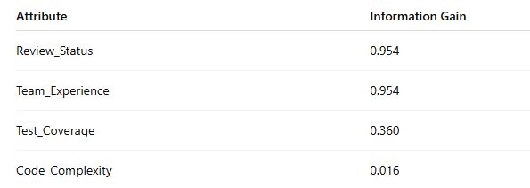
The highest information gain is 0.954, shared by Review_Status and Team_Experience. You can select either one as the root (both perfectly separate data).

If root = Review_Status:

Review_Status
├─ Not_Reviewed → Buggy = Yes
└─ Reviewed → Buggy = No

If root = Team_Experience:

Team_Experience
├─ Low → Buggy = Yes
├─ Medium → Buggy = No
└─ High → Buggy = No

